# **Automated car parking system**

**Abstract-**The main aim that we have is to create a completely automated car parking system with minimal human interference. With the rising population in the world, time is of the essence and hence we need to minimize the time taken by trivial activities such as finding a place to park in a busy place and avoid traffic congestion. We have seen in existing systems sometimes accidents can occur in parking situations by cars going at high speed o caused by frustrated drivers unable to find a parking space for a long period of time. In our project we propose a smart and automated car parking model that will help the user in booking their parking spaces beforehand and the vehicle will be able to park automatically once in the parking zone .The difference between our project of automated car parking systems is we hope to minimize human interaction as much as possible and make both the vehicle and the parking area fitted with sensors that will help us execute a safe and efficient way of parking. Hence, we aim to provide a completely safe and automated experience that is robust and can be implemented in real time and hopefully be implemented as the general norm for parking systems in the future.

## 1. INTRODUCTION

In the 21st century finding a free car parking slot has become a mind-numbing process, especially for people who travel in the morning to work or are following their daily routine, they find it highly difficult and challenging to get a parking slot for their cars. Moreover, the parking slots are never user-friendly and provide no logical data about the availability of the spot unless the user visits it manually.

These kind of problems are faced regularly by every individual because the factor of uncertainty is very high and there are not many possible solutions in existence for solving the issue that may benefit the users by saving their time or keeping their mental state happy and carefree.

In our ever populating cities and districts to find parking space is becoming increasingly difficult as traffic increases. Drivers have to go back and forth desperately looking for parking spaces wasting their valuable time, fuel consumption with increased likelihood of causing accidents. With the help of wireless network technology we propose remote parking monitoring and automated guidance which will help save a lot of time.

In the existing system we can see that some supervision is required for the parking system and it not fully automated. The driver has to make sure that the car is parked in a spot without disturbing the convenience of others. In most cases the main problem is finding the spot and trying to secure the spot for parking which in turn leads to increased stress level for the person driving the car.

Moreover, the relative analysis of the data is structural to the implementation of the parking procedure.

Nowadays, in this busy world it’s really hard for a person to find a spot for parking. The current parking system doesn’t give the user a specified parking slot inside the area. Parking in general in a long and timeconsuming process and we hope to provide a solution to alleviate this problem.

## 2. MODULES

### A. Sensor level module

Here we are implementing CMOS, ultrasonic and Electro-magnetic sensor for the conception of detecting the presence of the car in the parking slot. Then with the help of an arduino and modem we transmit the signal wirelessly to the receiver.

1. *Billing/Payment module***:**

In the car parking area we collect information about the driver and store it in a database and using an app we are able to provide options for payment online after which they can park their car and while they exit billing is done and any additional charges are added on to their account.

1. *Program level module***:**

In programming level we process the received signal with mega arduino to find the free parking slots and obtain results. Then it’s transmitted to the server with the help of the modem.

1. *Display level module:*

In display level there are two aspects which are taken care of. Firstly, the parking area once booked changes the color of LED in the parking slot to indicate that it’s taken. Secondly, the user’s mobile application and the server works at the client level and admin level. This in turn helps the user to understand the processes happening in real time with the help of the display unit in the system optically.

## TABLE 1: PERFORMANCE REVIEW

|  |  |  |  |  |  |
| --- | --- | --- | --- | --- | --- |
| **NO** | **Name** | **Methodology:** | **Advantages:** | **Limitations:** | **Drawbacks** |
| 1 | *A Design of*  *Automated*  *Parking System for Shopping*  *Centers in Metro*  *Manila* | Taking survey of parking area in different parts of the city and forming the statistical data. Using the data obtained the average waiting time, space required and other crucial information were gathered. Finally a multi-level spiral ramp was proposed and entry and exit will be monitored by sensors. | Spiral ramp helps to save space.  Better service quality. | Cause congestion during peak out-bound movements | The whole point of the parking system was to save time as well as space but this methodology solves only one of the two at most cases. |
| 2 | *The development and simulation of a smart parking guidance system* | The parking guidance system consists of software and hardware. Proximity sensors are fixed on the parking slots to find out if the place is occupied. Using a mobile guidance app the slots are given. | LED lights are mounted on all parking slots for easier vision. | The proximity sensors may give defective results. | Working with a mobile while driving is considered bad for safety. |
| 3 | *Smart Car*  *Parking System Solution for the Internet of Things in Smart Cities* | This has three partsThe parking slot, cloud and the user end part. Sensors are put in parking slots in the area and through mobile app we can see which parking slot is free using IoT and we can park in that area. | Free parking slots can be easily  recognized due to the sensors. | Chance for a random guy to park in an area which was free a few seconds ago. | No tickets so slot gets occupied before the person goes to that spot. |

|  |  |  |  |  |  |
| --- | --- | --- | --- | --- | --- |
| 4 | *Intelligent Smart*  *Parking*  *Algorithm* | It uses intelligent smart parking algorithm technique with the help of a rotary parking system with electronic addons which facilitates easy access, safety, power efficiency and optimal space usage. | High reliability to users, fuel productivity  and lesser maintenance  cost to management. | CMOS  sensor works with respect to light and noise in the image makes it defective. | The vehicles do not usually stop at a rotary. Therefore, they are not suitable when there is high pedestrian movements. |
| 5 | *Automated*  *Parking Space Detection Using*  *Convolutional*  *Neural Networks* | The computer vision with a single camera, using CNN helps us to know if the parking slots are free or occupied. | The data sheets counts human passing in the parking slots doesn’t trigger the result to occupy. | In case of change in  climate results in false result as the image proposed  will have more noise in data. | In case of large area it is not practical or economical to have cameras without  obstructing other parking slots. |
| 6 | *An IoT-based EParking System*  *for Smart Cities* | This E parking system uses smart parking system, parking meter and IoT. Sensors are present in the in every parking slot and it has local and central parking management system. | Reserve a parking slot, vehicle is parked improperly detected easily. | Hardware and software requirement of the setup is costly to maintain regularly. | Since all the parking slots can be reserved there is no chance for prioritizing. |
| 7 | *Automated*  *Vehicle Parking*  *System And*  *Unauthorized*  *Parking Detector* | It uses RFID, GSM module and Infrared sensor to set up the parking mechanism. | It requires minimum  usage of selfinteraction. | There is chance of traffic congestion. | Can’t recognize difference between a car and other objects. |
| 8 | *Secure Automated Valet Parking: A*  *PrivacyPreserving*  *Reservation*  *Scheme for*  *Autonomous*  *Vehicles* | It uses automated valet parking mechanism to park the cars safely. The user drops the car and uses his smart phone to drive the car till the parking lot then the AV can park itself in the spot. | Saves time for the user as he don’t have to park the car in the specified area manually. | In case of user’s phone runs out of battery it’s impossible to get the car using AV. | It’s highly unsafe since the AV can’t stop the car in certain anomalies. |
| 9 | *Path Loss Models for Low-Power, Low-Data Rate Sensor Nodes for*  *Smart Car*  *Parking Systems* | Path loss model for low power and low data rate with radio frequency sensors in the parking spots as transmitter, receiver and intermediate communication  nodes. WSN increases the energy efficiency of the system. | It can be used in both indoor and outdoor. | There are chances in which the sensors read values are faulty. | Most common issues are radio interference, electromagnetic interference  and antenna problems. |
| 10 | *Smart Parking - An Integrated Solution for an Urban Setting* | They use CCTV camera infrastructure coupled with using image processing and machine learning to detect the empty parking slots and the using the app the user can find the nearest parking slot. | The user can find a spot near the  destination  where the user wants him to go. | Image  processing  fails to identify the free slot is car is parking in front of free spot. | Wastes time as well as fuel for the extra travel time to the parking slot. |

The above **table 1** provides the pros and cons of various published papers related to parking mechanism compiled together into a performance table.

## 3. DESIGN

The system should have clear-cut information and guide- lines on how a driver is able to interact with the system to find a free space for the successful automated parking of the car. There should be the presence of administrators and proper management for a fully functioning car park.

There are a variety of components that are required for the project for its proper functioning and execution with minimal interference from humans.

### A. Ultrasonic sensor

These work under the sensor level which helps us to detect the car during the entry and exit points. The fig 1 shows the pictorial representation of an ultrasonic sensor.

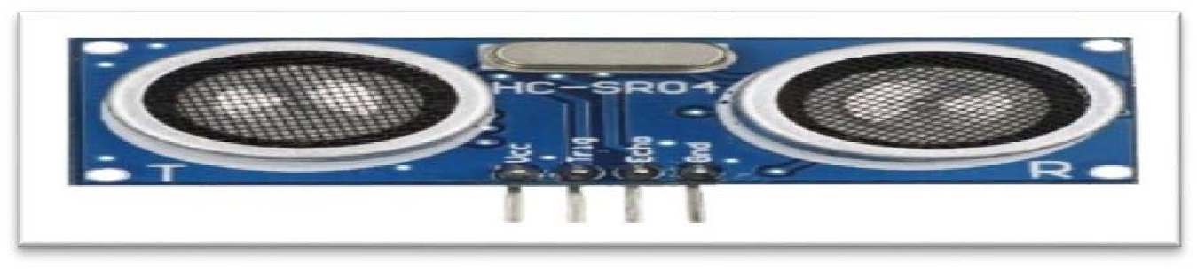

## Fig.1:Ultrasonic Sensor

### B. LEDs

They are used at display level where the people can see the process happening with respect to color produced by the LEDs. In fig 2 the LED can be seen.



### **Fig.2: LED** C. Arduino Mega

A programming level circuit board to configure the programs of the main server. We can see an arduino mega in fig 3 accordingly.

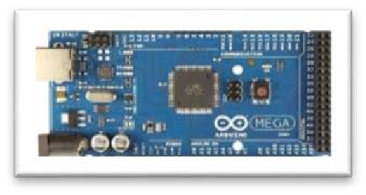

## Fig.3: Arduino Mega

### D. Arduino uno

As a programming level circuit it helps us to communicate between the programming of the router and the sensory level components. We can see an arduino in fig 4 restively.

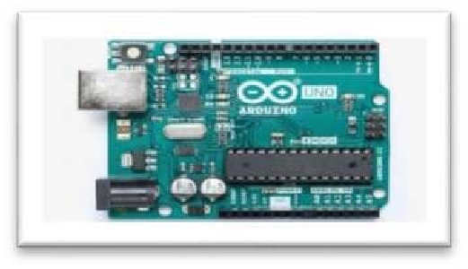

## Fig.4:Arduino Uno

### E. Wi-fi Modem

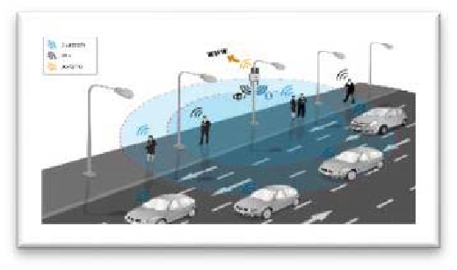Used for wireless communication. In fig 5 we can see how the wireless sensor are implemented in the system.

**Fig.5:Wi-fi Modem**

## 4. ALGORITHM

### A. Parking Allocation Mechanism

ReadSensor ( ) AllocationSpaceMatrics(n,m) = = () If ReadSensor ()-> Car Assign carID

int size = SizeCheck(carID) int type = TypeCheck(carID)

SearchAllocationSpaceMatrics(carID, type) Address = SearchAllocationSpace (carID, type) UpdateAllocationSpacematrics()

1. *Read Sensor* ReadSensor() if metalSensor() is metal

_then: if weight() > 1000kgs

_then: if wheels() == 4 _then: if State() is on return car;

1. *Allocation and search* SearchAllocationSpace (carID, type ) If type is small, then: p=1;

Else if type is medium, then: p=2; Else if type is large , then: p=3; For( q=1; q

<=m ; q= q+1); AllocationSpacematrics(p,q) = = 0; then:AllocationSpacematrics(p,q)=1;

In the above given algorithm we use three parts namely the Parking allocation mechanism, Sensor read and the allocation search. These algorithms together form the base of the system’s program and helps us to perform the processes of the automated parking system.

The read sensor uses digital signals from the sensor which are used to detect the presence of the car and helps in identification of the obstruction in the parking slot.

Next comes the Parking allocation mechanism where the size and type of the car along with other crucial information are taken into account and then the processes are being called upon in order to allocate the suitable parking slot.

The Allocation and search algorithm is used to find the exact spot for the car with the details of the car identification and type. It also takes in account the vital information such as the user’s destination and preferences to allocate the best possible spot.

These three algorithms are the core for the further implementation of this project with various capabilities and possibilities which finds the perfect and suitable parking spot with respect to the norms provided by the user accordingly.

## 5. BLOCK DIAGRAM

The block diagram in fig 6 shows us the schematic presentation of the general arrangements with components of the process in a detailed manner with a clear illustration about the embodiment of the processes.

Firstly, the client requests information from the mobile application. In this case the client can request where parking is available, what location the car was parked, payment information etc.

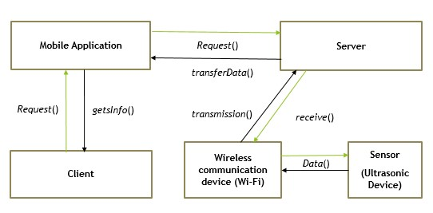

## Fig.6: Block Diagram

The mobile application then gets data stored from the database in the server and solves query of the user in real time by understanding the functionality of the processes.

The sensors detect whether the parking slot is available or unavailable and transmit information wirelessly to the database and then to the user. Registered vehicles may be parked in the available space and the user may locate the car at any time using the mobile application.

### **6. Project Architecture**

The project architecture gives us a graphical representation of concepts which are the part of the framework including their components elements and principles as shown in fig 7 The three levels in the architecture diagram namely the sensor level, program level and client/display level.

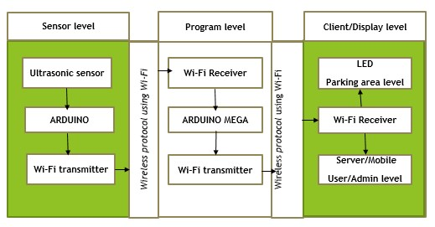

## Fig.7: Project Architecture

The architecture diagram gives us the description on how the communication between various elements and components happens in real time together with the phenomenon behind the structural integrity of the system in a well descriptive manner. This various levels helps us to distinguish between one another and maintain overall stability of the system through balanced operations with respect to the given regulations effectively.